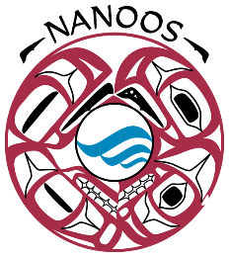

NANOOS Next 5-Year Effort: 2020 Timeline

For any questions, please contact NANOOS Program Manager, Nick Rome (nrome@uw.edu).

DATE | ACTION | POINT
25 June | Expressions of Interest (EOI) process announced | PIs
25 July | All EOIs due to janewton@uw.edu and nrome@uw.edu | PIs
Early August | EOIs prioritized by NANOOS Governing Council Executive Committee | GC Exec Comm
Late  August | Further Management deliberation with NANOOS Governing Council Executive Committee to finalize budget and proposal scope | GC Exec Comm
31 Aug | All included PIs notified | PIs
Sept | Proposal writing begins | NANOOS
30 Sep | All sub-budgets due to their respective institutional fiscal offices | PIs
30 Oct | All sub-budgets, SOW, budget justification due to APL-UW | PIs
30 Nov | Proposal submission target date | NANOOS

